THIS IS NO LONGER USEFUL – SEE IMMUNEXPRESSO for data mined Immune-centric network of cytokines and cells in disease context identified by computational mining of PubMed

Mathematical modelling of immune response in tissues – Su et al 2008

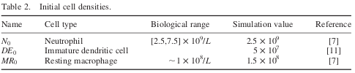

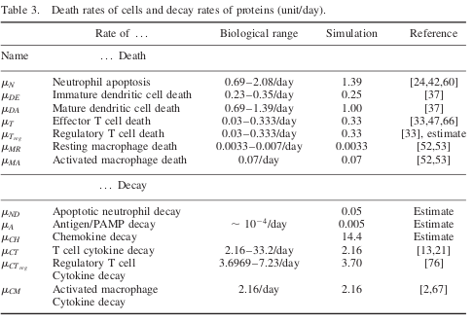

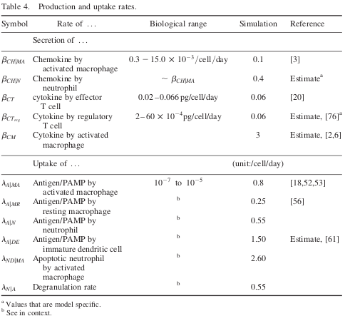

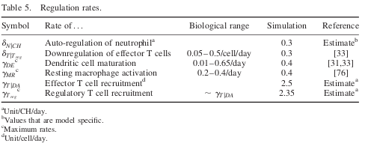

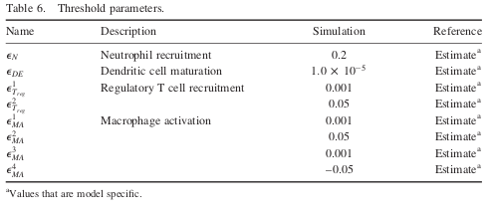

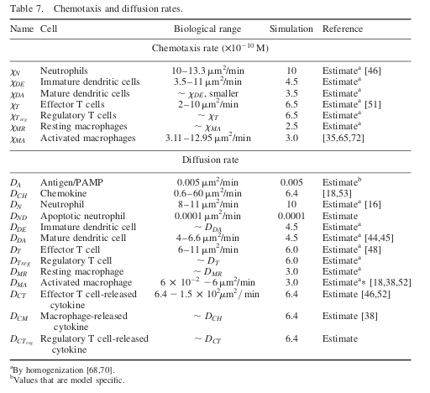

Modeling the effects of treating diabetic wounds with engineered skin substitutes – Waugh 2007

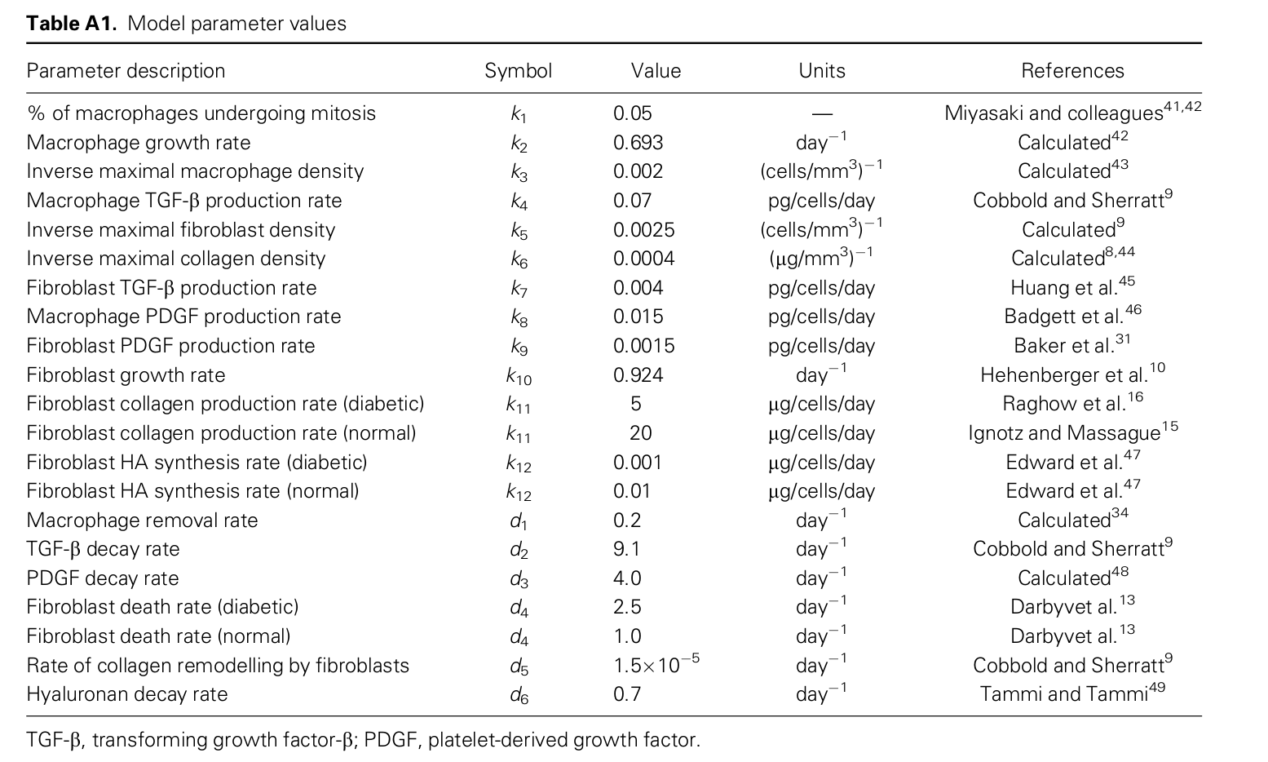

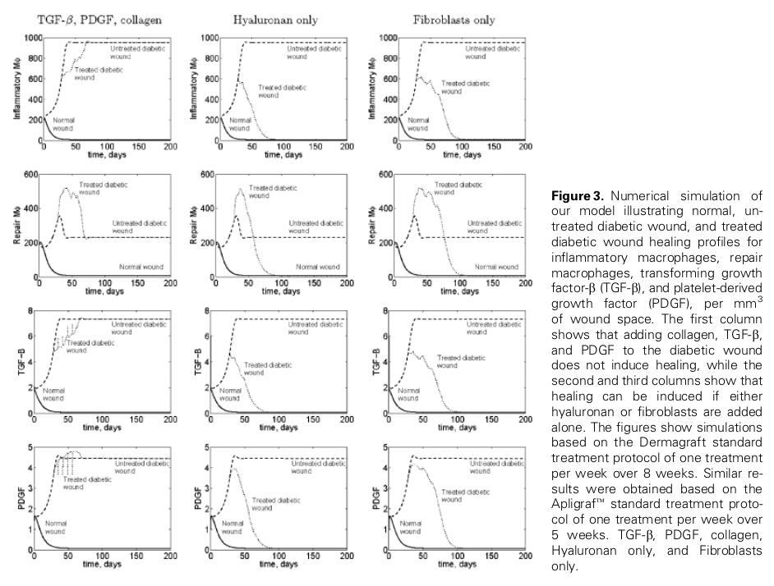

Inflammation in Wound Repair Eming 2007

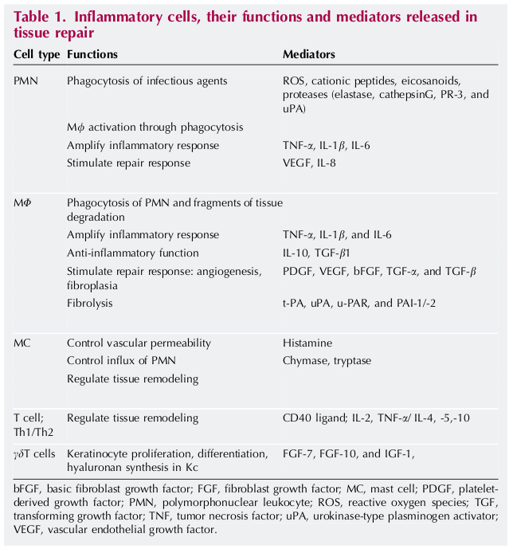

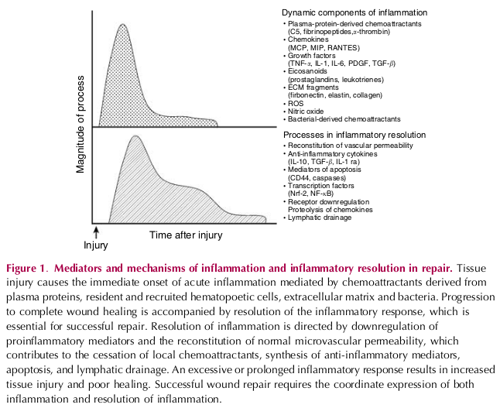

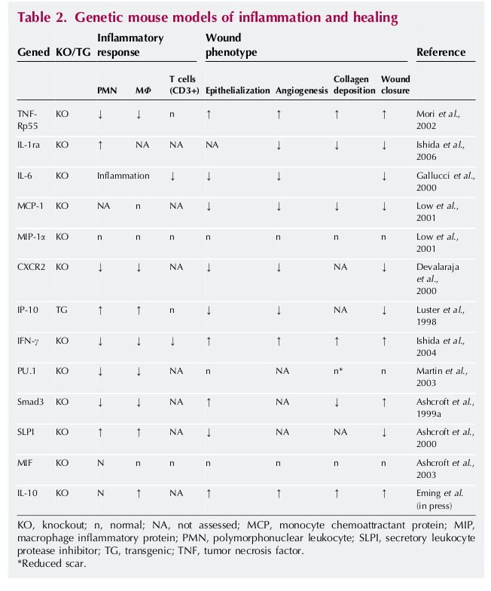

DISORDERS OF THE IMMUNE SYSTEM IN SEVERELY BURNED
PATIENTS
Fayazov 2009

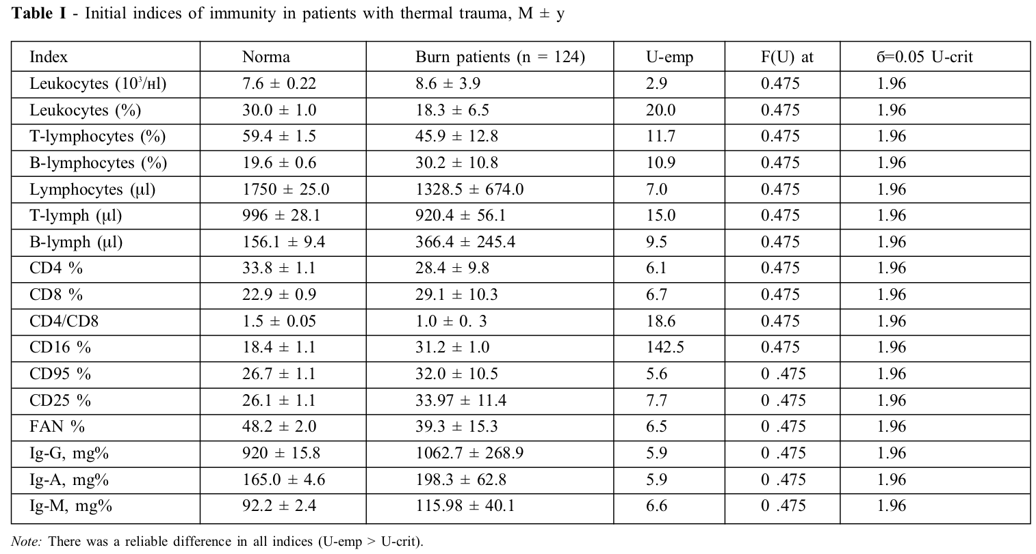

A Study on Biomarkers, Cytokines, and Growth Factors in Children with Burn Injuries
Abdel-Hafez (2007)

THIS PAPER ALSO CONTAINS CORRELATIONS BETWEEN SPECIFIC CYTOKINES

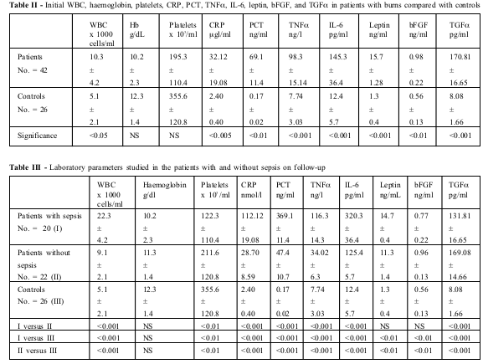

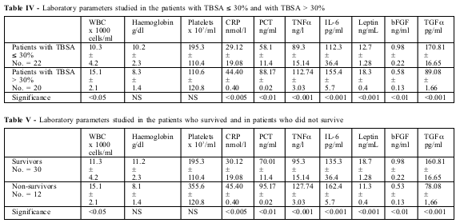

Inflammatory markers in patients with severe burn injury
What is the best indicator of sepsis?
Lavrentieva et al. 2006

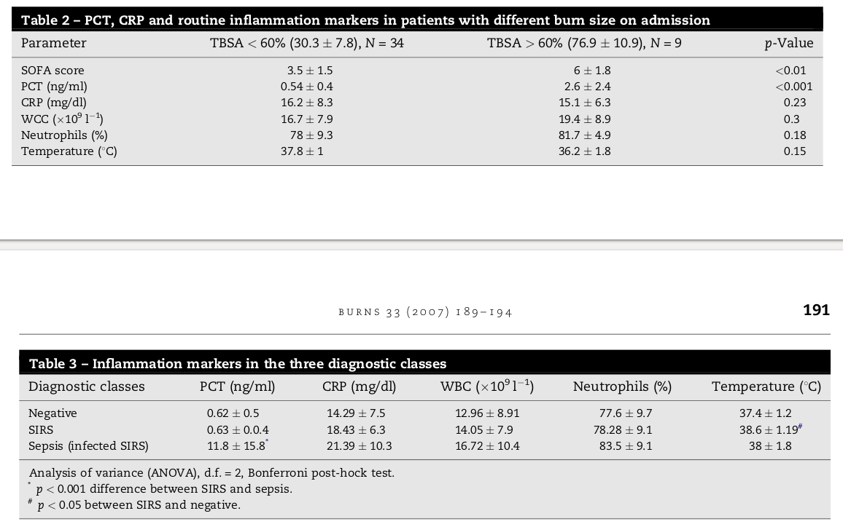

Serum Enzymes in Thermal Injury (2007) – bhagwat et al.

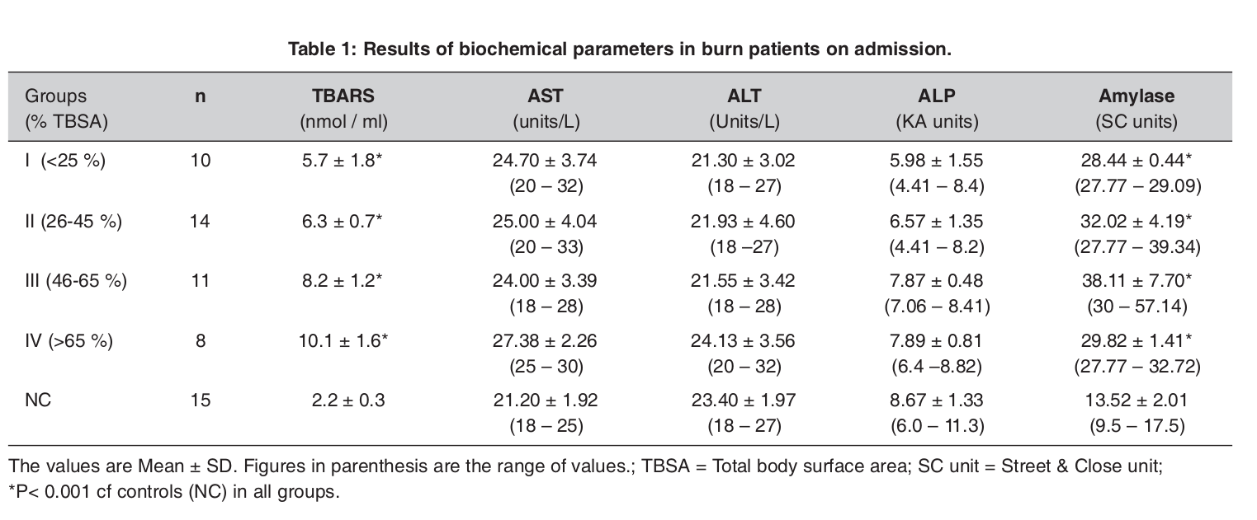

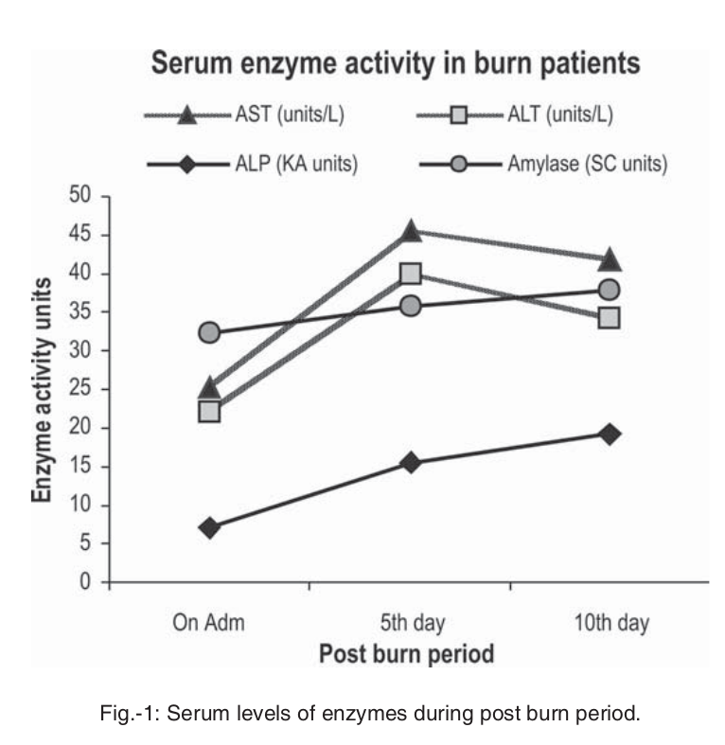

Extracellular Matrix Reorganization During Wound
Healing and Its Impact on Abnormal Scarring (2015)
Xue and Jackson
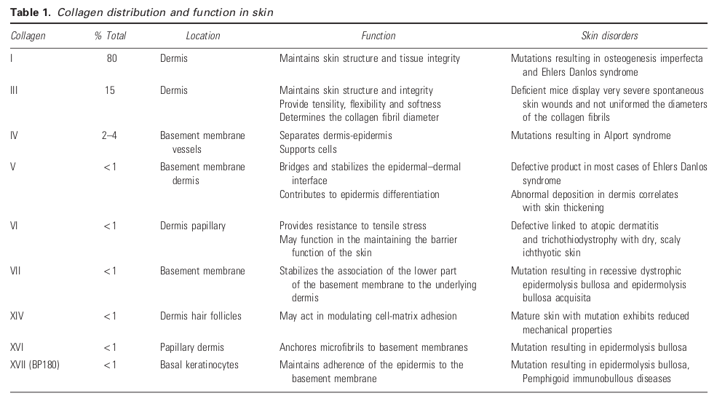
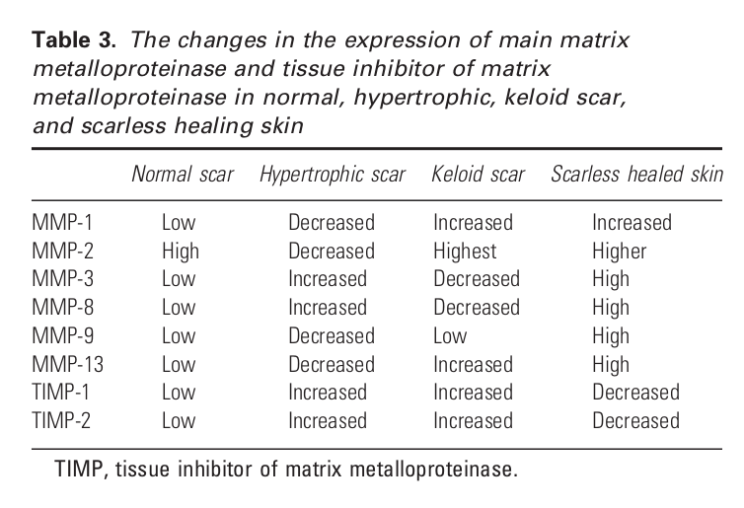
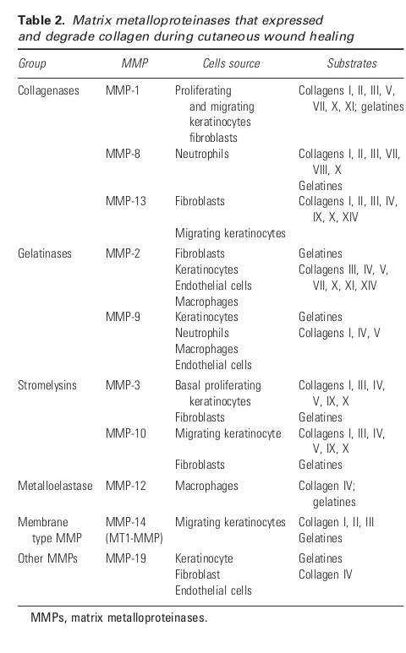

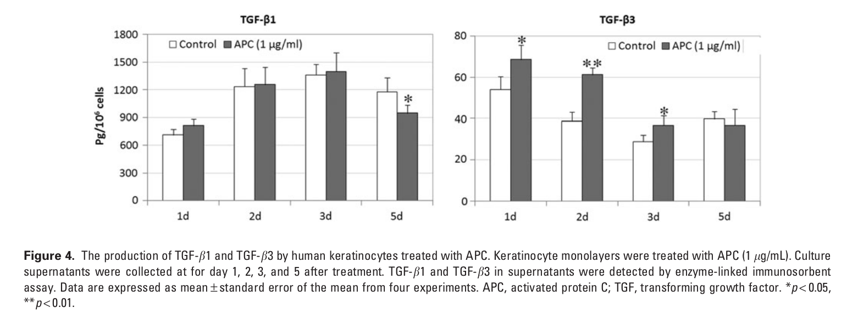
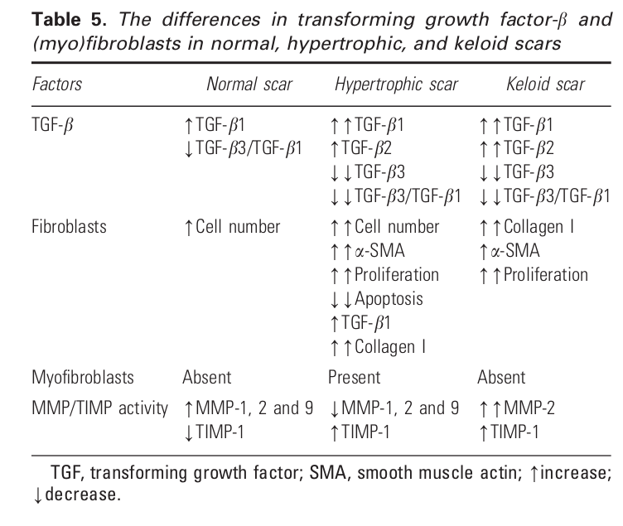

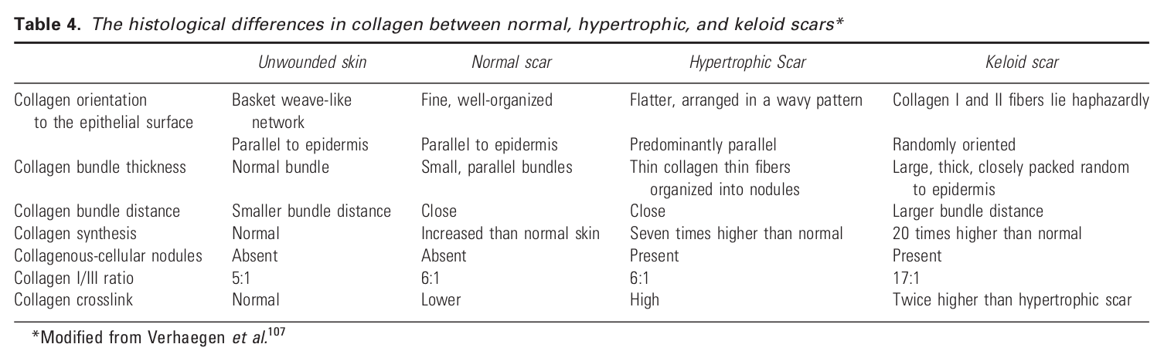

PROTEIN COMPOSITIONS FOR PROMOTING WOUND HEALING AND SKN REGENERATION Patent US 7,312,198 and 7011965B2 – Zoltan kiss

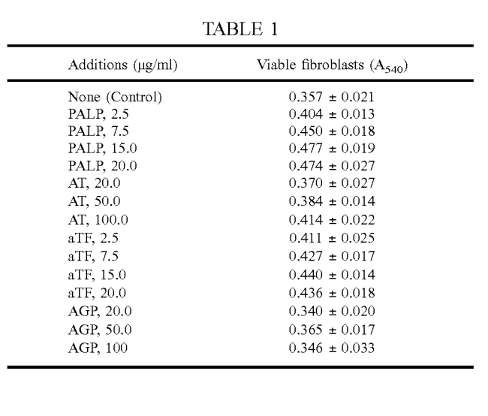

#

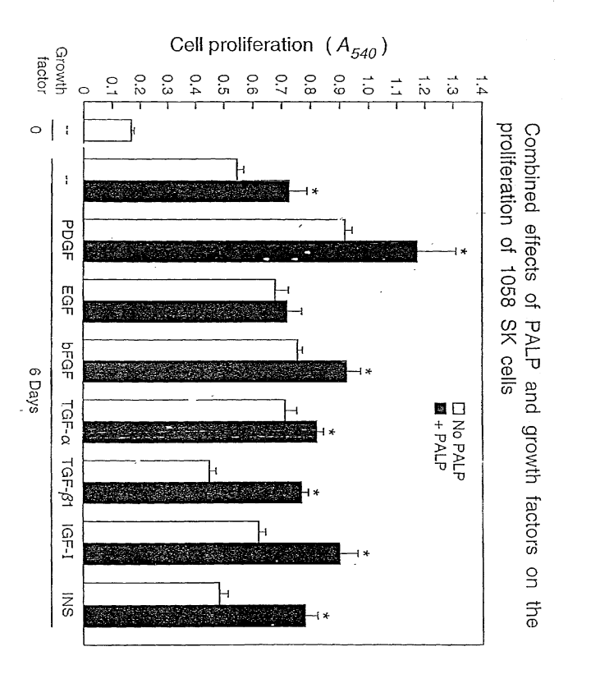

Rate of Healing in Skin-Grafted Burn Wounds – Jewell et al. 2007

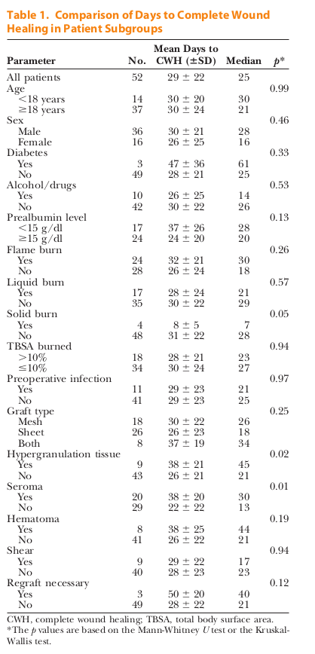

Model Parameters

A morphoelastic model for dermal wound closure – Bowdenet al. (2016)

